https://dretssocials.gencat.cat/ca/ambits_tematics/civisme_i_valors/observatori/
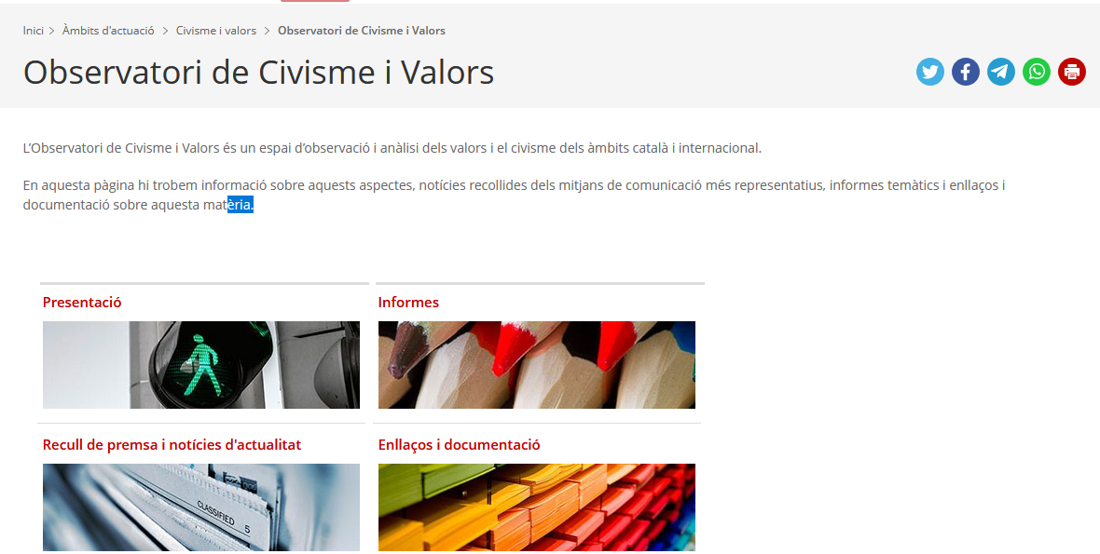
https://dretssocials.gencat.cat/ca/ambits_tematics/civisme_i_valors/observatori/enllacos/
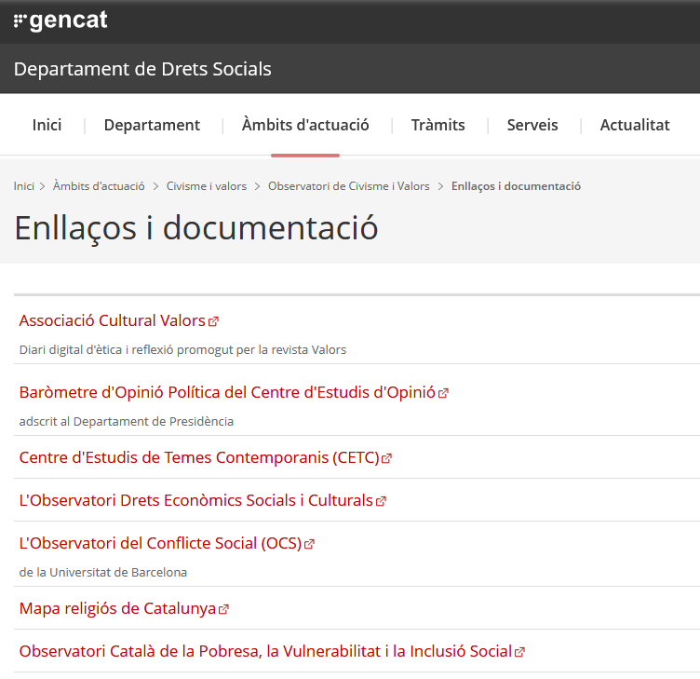

https://dretssocials.gencat.cat/ca/ambits_tematics/civisme_i_valors/observatori/informes/
